Milestone 4 : Creation of Access Control Lists(Create ACL)

Click New to create a new ACL(Create)
- Enter the following details:
  - Type: record
  - Operation: create
  - Name: u_institution_details
  - Active: true
- In the Requires role related list, add:
  - bb2 (custom role)
- No need to add any Data condition
- Save the ACL Record
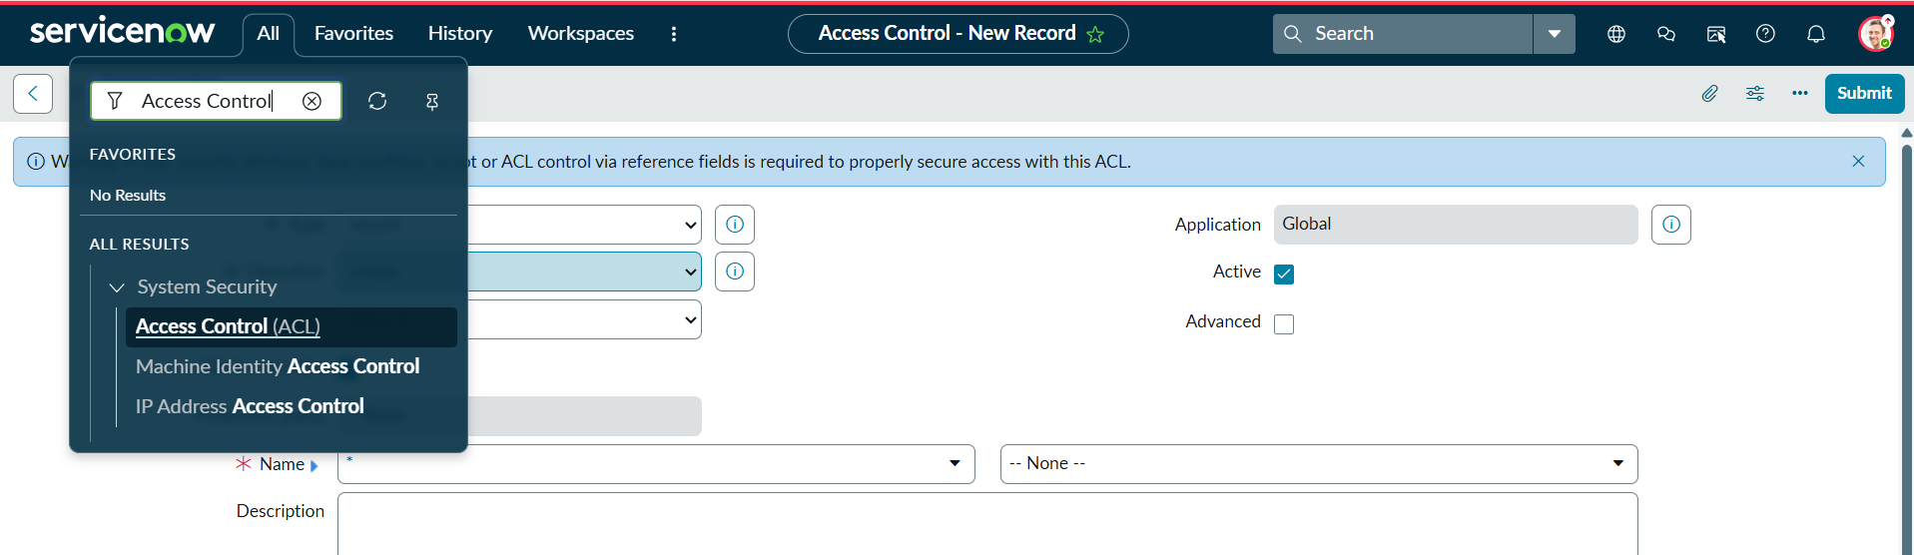
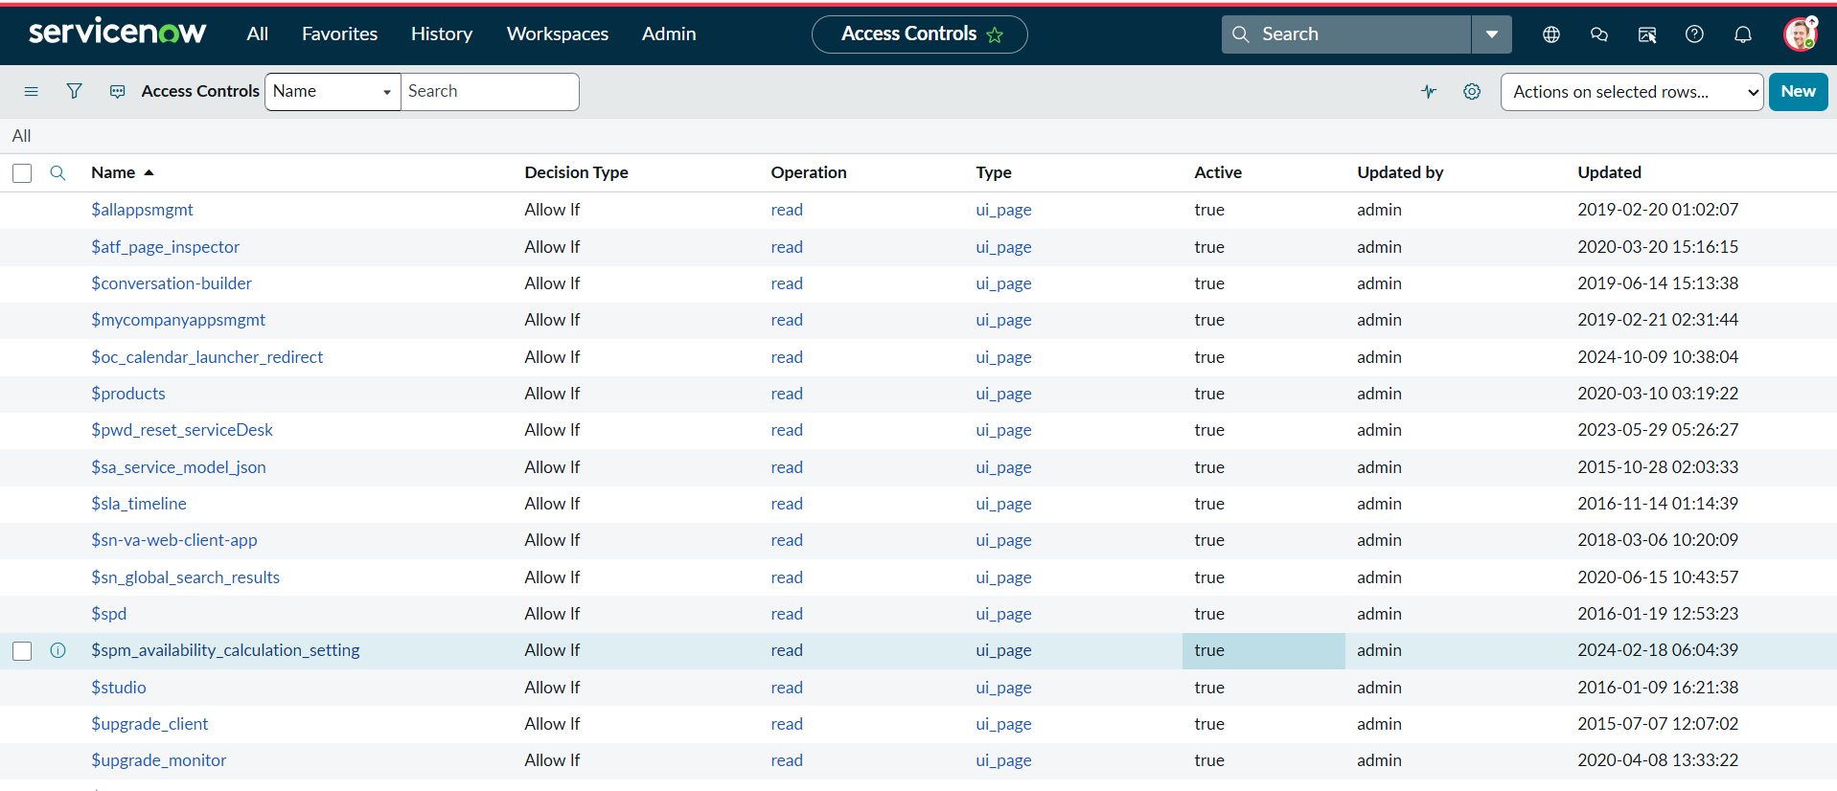
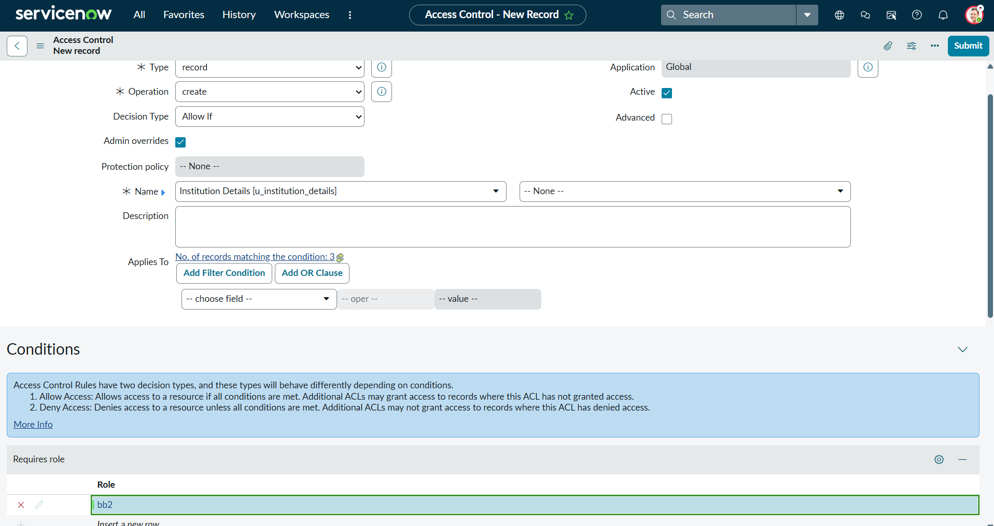
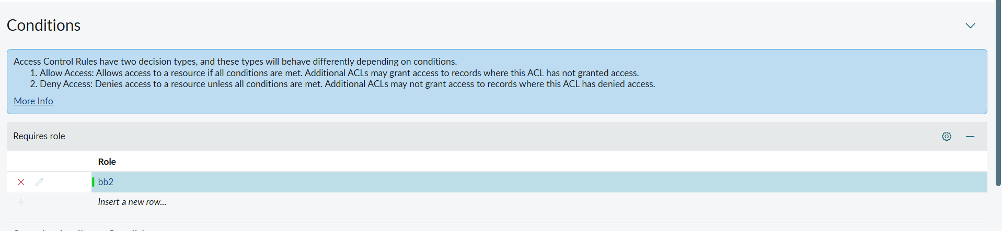

Verify :
- User with bb1 &bb2 roles can view only EEE branch records b New Button
